

**Project Report**

***Electricity Company Management system -ECMS-***

**Defining the Problem Treated**

The Electricity Company Management System (ECMS) is a focused project addressing the challenges faced by a national electricity company in managing power consumption, injection and billing. The objective is to develop an efficient system.

The ECMS tackles the complexities of managing electricity consumption, billing, and the integration of photovoltaic electricity within a vast customer network. Utilizing advanced data structures such as hash tables, binary search trees, AVL trees, and heaps, the system aims to streamline data access, optimize operations, and enhance the overall customer experience.

**Project Objectives**

1. Efficient Data Organization:

The ECMS employs hierarchical structures like hash tables and BSTs for quick and efficient data retrieval, crucial for managing extensive datasets.

2. Optimized Operations:

Leveraging AVL trees and heaps, the project focuses on optimizing billing, departmental performance analysis, and customer summary retrieval, ensuring system responsiveness.

3. Dynamic Budget Management:

The system incorporates dynamic budget adjustments based on departmental performance, showcasing adaptability to the company's financial dynamics.

1. User-Friendly Results Display:

The ECMS facilitates user-friendly functionalities, such as generating individual customer bills, summarizing bills for specific regions or cities, and displaying departmental rankings.

**Explanation of the Data chosen:**

In the context of our project, we generated datasets to simulate the electricity management system for the national network of a fictional Algerian electricity company. The datasets were created to represent the geographic structure of Algeria (regions, cities, districts), along with the details of individual customers. Two tables are created for the manipulation of the data format chosen in CSV files containing tables for previously mentioned instances.

Here's how we formulated and utilized these datasets:

1. **Regions, Cities, and Districts Dataset:**

We obtained data for regions, cities, and districts from a publicly available GitHub file *₁. Then we have modified and adapted this data to suit the needs of our project. Each entry in the dataset includes:

- Region ID - Region Name - City ID - City Name - District ID - District Name

For example ***Figure 1***

|  |  |  |  |  |  |
| --- | --- | --- | --- | --- | --- |
| Region_ID | Region_Name | City_ID | City_Name | District_ID | District_Name |
| 01 | Adrar | 01 | Adrar | 001 | Adrar |
| 01 | Adrar | 01 | Adrar | 013 | Ouled Ahmed Timmi |
| 01 | Adrar | 02 | Aoulef | 022 | Timekten |
| 02 | Chlef | 01 | Abou El Hassane | 060 | Talassa |
| 02 | Chlef | 12 | Tenes | 062 | Tenes |
| 05 | Batna | 19 | Theniet El Abed | 156 | Oued Taga |

|  |  |  |  |  |  |
| --- | --- | --- | --- | --- | --- |
| **05** | **Batna** | **12** | **Merouana** | **152** | **Merouana** |

|  |  |  |  |  |  |
| --- | --- | --- | --- | --- | --- |
| 06 | Béjaïa | 10 | El Kseur | 229 | Toudja |

***Figure 1***: Dataset sample of geographic structure of Algeria

**2. Customers Dataset:**

To represent the households within the districts, we generated a customer dataset using data sourced from «https://www.bard.google.com». Each customer is initialized with the following parameters:

- First Name - Last Name - Region - City - District - Number of Family Members - Bank Account

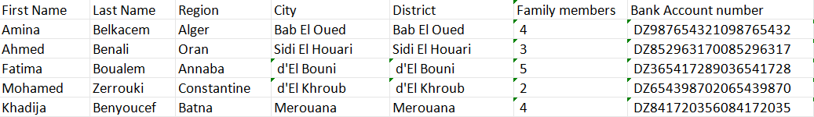 For example ***Figure 2***

***Figure 2:*** Dataset Sample of cutomers information

Additionally, a unique customer ID was generated based on the region, city, district, and electricity account number, ensuring a distinctive identifier for each customer by concatenating the followings:

Customer_ID = region_id + city_id + district_id + electricity account number

The customer ID generation process, for instance, might look like this:

|  |  |  |
| --- | --- | --- |
| Khadija | Benyoucef | **512152**841720356084172035 |

**Solution Explanation**

* **ADTs & design choices**

*****Where and how this adt is used; why?->Time complexity*****

1. Hash Tables: Lina²
2. Binary Search Trees: Wissam
3. Heaps: Nouha
4. //AVL: Nouha

* **Results**

- Answer the question 7; using comparative tables (time; space; efficiency)

- Give results summary of how the program runs including guidelines (examples of running)

**Team members tasks**

* **Nourhane Mami**
* **Slama Lina Nour**
* **Lakhdari Wissam**
* **Lina**

**Appendix**

You may wish to put in the appendix various screen shots from your system (although some screen shots will probably need to appear with the explanations of your system in the main part of the report)

**References**

DO NOT FORGET THE SCANNED PAPER!